General Welfare Requirement: Documentation
Providers must maintain records, policies and procedures required for the safe and efficient management of the settings and to meet the needs of the children.
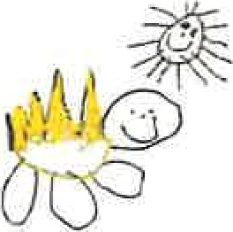
Gorran Pre School
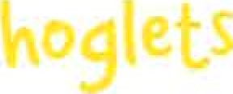
Record Keeping
5.2 Provider records
Policy Statement
We keep records for the purpose of maintaining our business. These include:
- Records pertaining to our registration.
Landlord/lease documents and other contractual documentation pertaining to amenities, services and goods.
- Financial records pertaining to income and expenditure.
- Risk assessments.
Employment records of staff.
Our records are regarded as confidential on the basis of sensitivity of information, such as with regard to employment records and these are maintained with regard to the framework of the Data Protection Act and the Human Rights Act.
This policy and procedure is taken in conjunction with the Confidentiality and Client Access to
Records policy and Information Sharing policy.
EYFS key themes and commitments
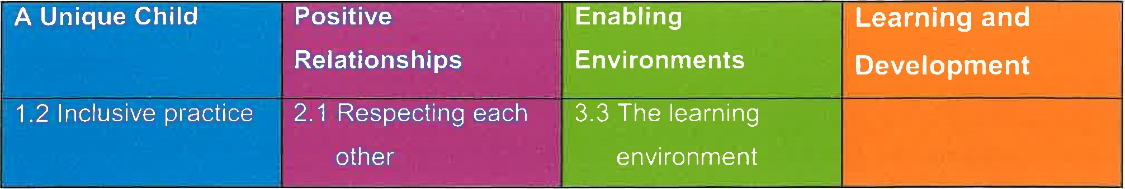

Procedures
- All records are the responsibility of the officers of the management committee who ensure they are kept securely.
All records are kept in an orderly way in files and filing is kept up-to-date.
- Financial records are kept up-to-date for audit purposes.
- Health and safety records are maintained; these include risk assessments, details of checks or inspections and guidance etc.
Our Ofsted registration certificate is displayed.
- Our Public Liability insurance certificate is displayed.
- All our employment and staff records are kept securely and confidentially.
Legal framework
Data Protection Act 1998
Human Right s Act 1998

Other useful Pre-school Learning Alliance publications
Accident Record (2010)
- Accounts Record (2005)
Safeguarding Children (2010) Recruiting and Managing Employees (2010)
Financial Management (2010)
Medication Record (2006)
Register and Outings Record (2010)
- Managing Risk (2009)
- Summary Complaints Record (2006)

This policy was adopted at a meeting of
Held on
Date to be reviewed
Signed on behalf of the management committee
Name of signatory
Role of signatory (e.g. chair)

Gorran Pre-School Hoglets name of setting
October 2019
October 2020 (date)

Michelle Beard

Michelle Beard

Pre-School Leader

